SUMMERVILLE CREDIT UNION · CONSOLIDATED MEMBER GUIDE
Reorder Card

Module: nFinia Digital Banking > Cards > Card Details > Order a New Card
01 PRODUCT SUMMARY

Reordering a card refers to requesting a new physical card for an account where a card already exists — typically because the card is worn, the magnetic stripe is damaged, or the chip is no longer working, but the card has not been lost or stolen. You can reorder a card using the Order a New Card feature in online banking.
When you reorder, the current card remains active until the new one arrives and is activated. A digital version of the new card is made available instantly, and the physical replacement is mailed to your address within 5 days. Set a PIN for the new card during the order process.

At a Glance
Attribute | Detail
Module | Cards > Card Details > Order a New Card
When to Use | Card is worn, damaged chip, or needs replacement without being lost/stolen
Current Card | Remains active until the new card is activated
New Card Delivery | Digital card instantly; physical card within 5 days
PIN | New 5-digit PIN required during order process
Related Features | Order New Card, Activate Card, Deactivate / Replace Card

02 KEY USE CASES

Use Case | Who Uses It | What They Do | Business Value
Replace a worn card | Member whose card's magnetic stripe or chip no longer works reliably | Uses Order a New Card to reorder a replacement | New card issued with the same account; old card active until new one is activated
Request a card for a new account holder | Joint account holder who needs their own card | Orders an additional card through Order a New Card | Separate card issued for the joint holder linked to the same account

03 STEP-BY-STEP GUIDE

Navigation: Log in to Summerville Credit Union online banking. Navigate to Cards, select your card, then click Order a New Card. Alternatively, use the Visa Debit / ATM Card Order Request form for non-OLB requests.
Step 1 — Arrive at the Dashboard
After logging in, you land on the Dashboard showing your account balances, recent payments, and quick-action shortcuts. Navigate to Cards in the top navigation bar, then select the account for which you need a replacement card.
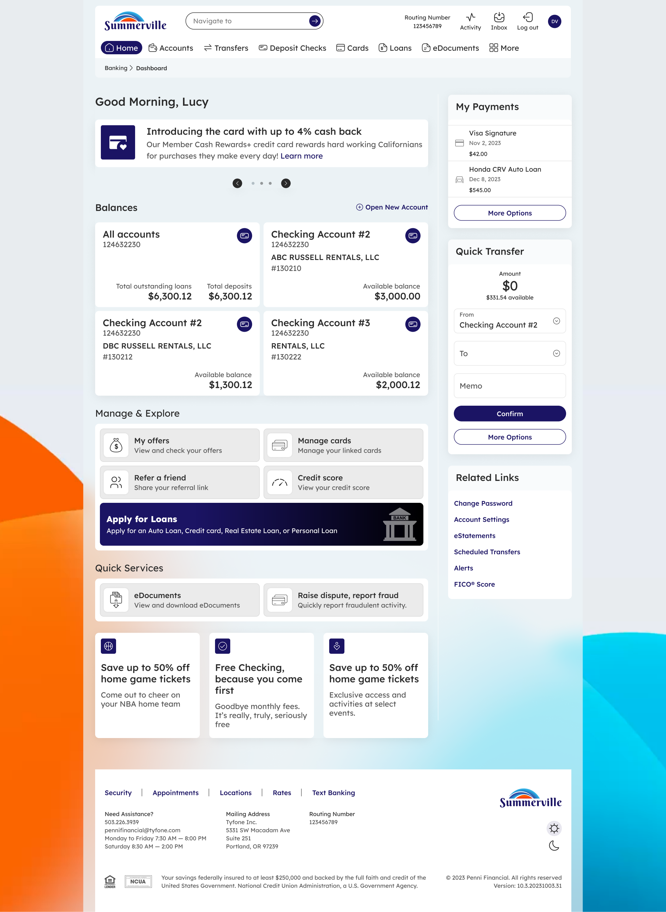
Step 1: Dashboard — starting point for navigation
Step 2 — Complete the Card Order
From Card Details, click Order a New Card. Select your account, card type, and design. Choose whether you want a physical card mailed to your address. Enter and confirm a new 5-digit PIN. Click to confirm your order. A digital card is available immediately and the physical card will arrive within 5 days.
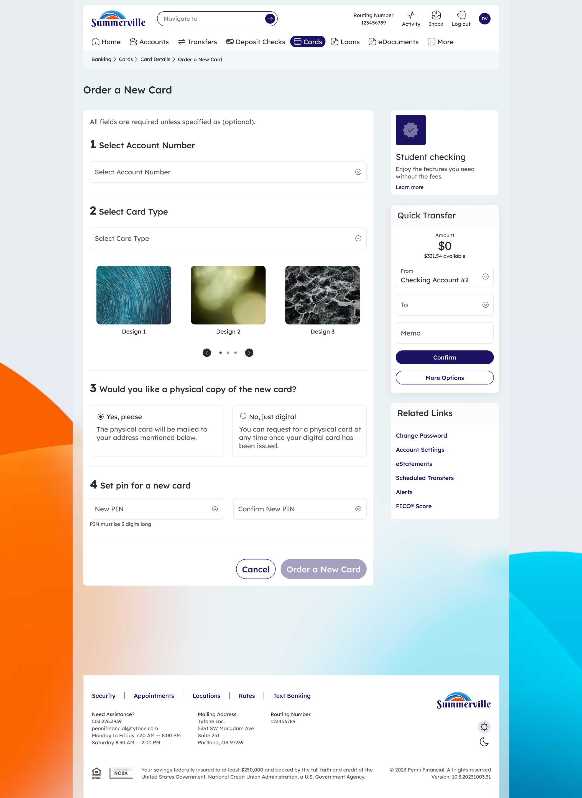
Step 2: Order a New Card form — complete details to reorder your card
Note: After your new card arrives by mail, activate it using the Activate Card feature in online banking before attempting to use it for transactions.

